# Kettles



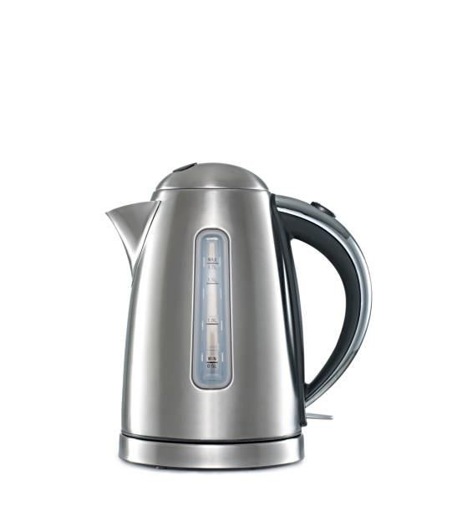BY

Kamalesh J

23AIA41

B.TECH AI & DS

Introduction:



* Title: "What is a Kettle?"
* Definition: A kettle is a kitchen appliance used for boiling water. It typically has a handle, a lid, and a spout for pouring. Kettles come in various types and serve different purposes.

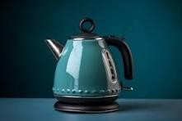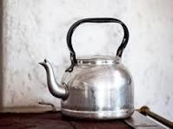

# Types of Kettles



* Traditional Stovetop Kettles
* 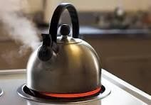Electric Kettles
* Whistling Kettles
* Smart Kettles with Temperature Control

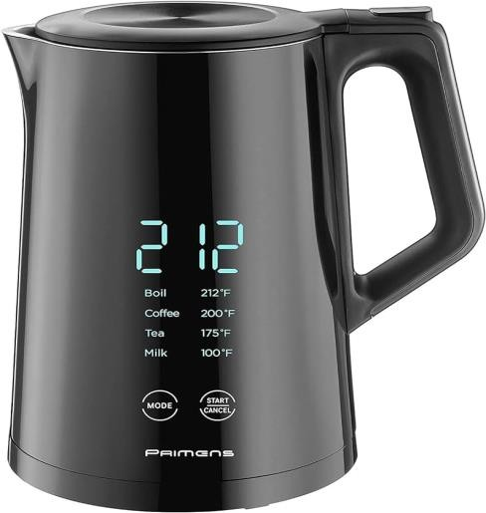

# Features and Benefits



* Quick Boiling: Kettles are designed for rapid water heating.
* Energy Efficiency: Electric kettles are more energy-efficient than traditional stovetop kettles.
* Safety Features: Many kettles have automatic shut-off and boil-dry protection.
* Stylish Designs: Kettles come in various designs to complement kitchen aesthetics.

# Tips for Proper Use



* Follow Manufacturer's Instructions
* Regular Cleaning and Descaling
* Use the Right Amount of Water
* Check for Safety Features
* Avoid Overheating



THANK YOU